**How to setup OBP for ubuntu**

[**https://apisandbox.openbankproject.com/consumer-registration**](https://apisandbox.openbankproject.com/consumer-registration)

Login to the platform and generate a key:

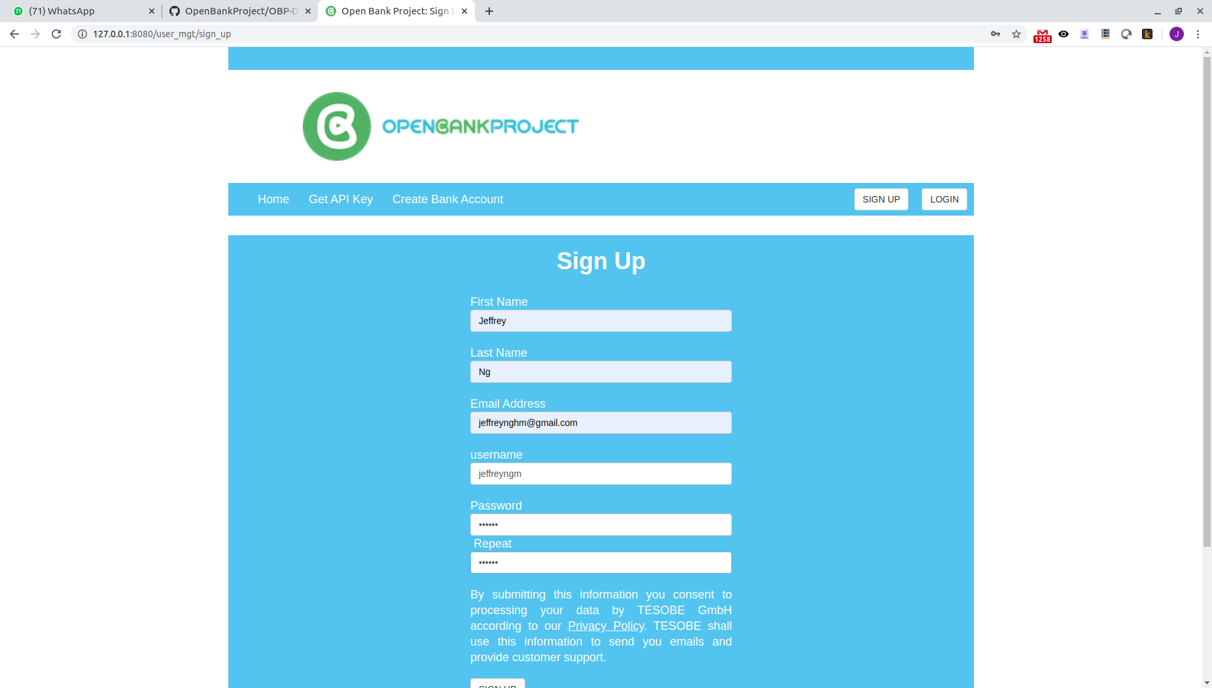

note down the username and password

next you will be asked to register the app:

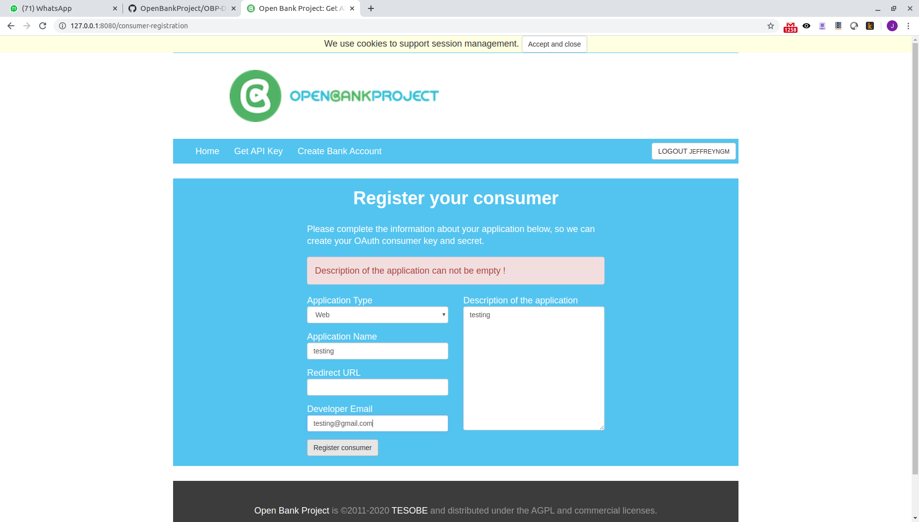

Next the consumer key will be provided:

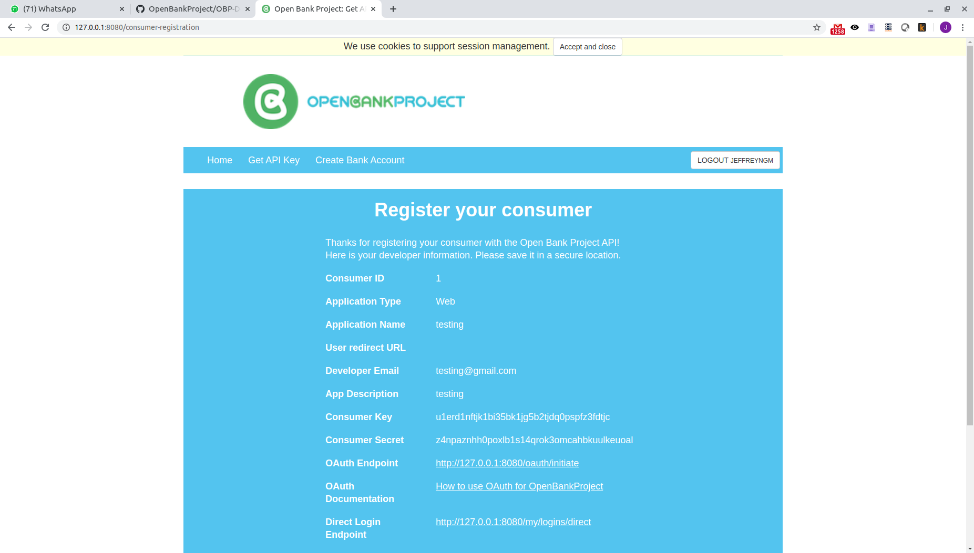

|  |
| --- |
| Note down the consumer key |
|  |

Create bank account:

use rbs and select currency being GBP

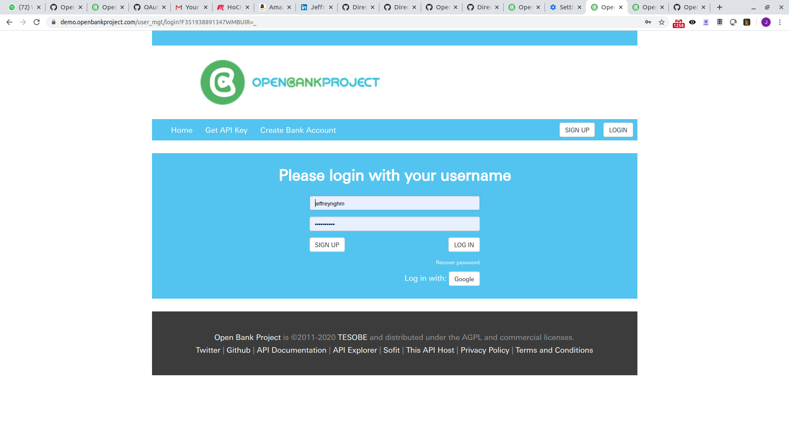

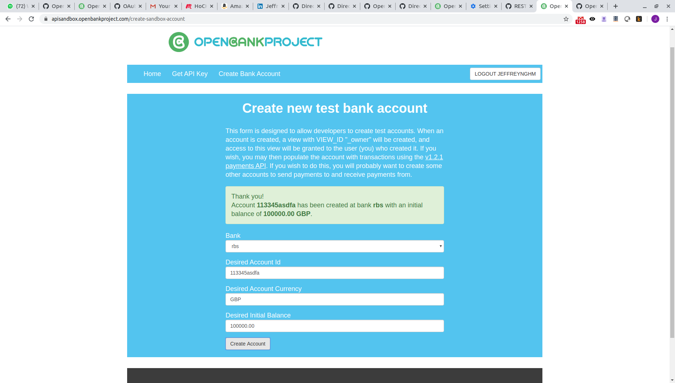

Then can run